Project Documentation
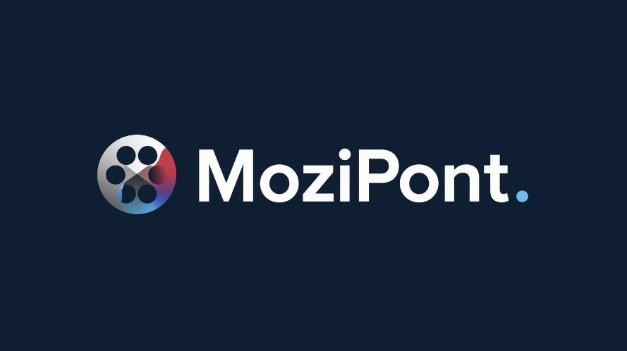
Mozipont Web Application

Premontrei Szakgimnázium és Technikum
Keszthely
2026
Software Tester and Developer
5-0613-12-03
Prepared by:
Palkovics Tamás Tibor, Vadász Dániel

Contents
Introduction 3
Database 5
Backend 6
Frontend 7
Software amd Tools Used: 8
Appendix 10

Introduction
This project was implemented by a two-person team: Tamás Tibor Palkovics and Dániel Vadász. The title of our project is: Mozipont.
The choice of topic was primarily inspired by our shared interest, as we both enjoy spending our free time in the world of movies and series. Our goal was to create a transparent interface that not only informs users but also helps them navigate through the content. We believe that the movie-watching experience is truly complete when we have the opportunity to share our opinions and choose new content based on the experiences of others. With the help of the application, visitors can read detailed descriptions, watch trailers, and make decisions based on these. Our primary aim is to help users find quality entertainment and assist one another through the power of the community.
At the start of development, it was important for us to offer something "extra" compared to existing solutions on the market. We felt there was a lack of applications that handle information gathering and personalized needs simultaneously. One of the most important innovations of our system is its ability to analyze user search history and offer intelligent, personalized recommendations based on it. This allows everyone to more easily discover works that truly match their taste.
Overall, the project demonstrates not only our technical knowledge but also our commitment to film culture. We hope that our web application will become a useful tool for those seeking relaxation in the future and contribute to revitalizing the film community life.
During implementation, effective teamwork proved to be one of the keys to our success. We divided the tasks equally—whether it was the visual world of the frontend or the logic of the backend—continuously supporting each other in overcoming technical obstacles. This cooperative attitude not only increased the speed of our work but also improved our joint problem-solving abilities. By combining our different professional strengths, we gained a wealth of new knowledge during the process.
During the development period, our communication skills and empathetic approach also developed significantly. We learned that open dialogue and constructive feedback are essential for quality work. This experience will be extremely valuable for us in our future professional careers.
Regarding time management, we followed strict planning and consistently met deadlines. The detailed schedule helped us avoid the rush at the end of the exam period and allowed us to close every development phase under calm conditions. Thanks to our organization, we managed to implement every function on time. We were assisted in this by the Gantt chart shown below, which allowed us to plan the timeline of the various workflows in advance.

Database

Backend

Frontend

Software amd Tools Used:
• Microsoft Office (Word, PowerPoint): Microsoft Word was used to create the complete project documentation, including design descriptions, technical explanations, and the project overview. PowerPoint was used to create the presentation for the final exam masterpiece, which was used during the project defense.
• Figma: We used Figma to design the web application's user interface. The page wireframes and visual layouts were created here, which greatly aided the development process by defining the application's structure and appearance in advance.
• Canva: The Canva online design tool was used to create the site's logo. The program allowed for the creation of quick and aesthetic graphic elements that fit the web application's branding.
• Inkscape: We used Inkscape to edit and refine specific graphic elements. By using vector graphics solutions, we improved the visual appearance of the site, ensuring that graphic elements appear in high quality at different resolutions.
• Google Drive: In the initial phase of the project, we used Google Drive for sharing and securely storing larger files. This made project files accessible from multiple devices and allowed us to save code snippets created at school for later use.
• VTK Moodle: Various stages and milestones of the project were uploaded to the VTK Moodle system. This provided teachers with the opportunity for continuous monitoring and feedback, and it was also where we received auxiliary materials and professional guidelines (e.g., database structure, backend code structure).
• Messenger: The Messenger application was used for shorter, quick coordination, discussing minor bug fixes, and sharing ideas.
• Discord: We used the Discord platform for discussing more complex problems, screen sharing, and collaborative coding, which enabled effective teamwork.
• GitHub: GitHub was used for the continuous uploading and management of the project's entire source code. This was the primary and official repository for the project, where every state of development can be tracked. The complete codebase and the development process are accessible and viewable for the Exam Committee on this interface as well.
• Visual Studio Code: The entire source code of the project was created in the Visual Studio Code development environment. The program's extensions and built-in features facilitated efficient and clean coding.
• Docker Desktop: With the help of Docker Desktop, we ran the database in a containerized environment, ensuring that the database could be started and used identically, simply, and reproducibly on every developer machine.
• Postman: We used the Postman application to test and verify backend endpoints, ensuring proper operation and correct data handling.
• Material UI: We applied the Material UI component library to develop the web application's user interface. The library's pre-made components and example codes contributed to creating a consistent, modern appearance.

Appendix
Gantt diagram:

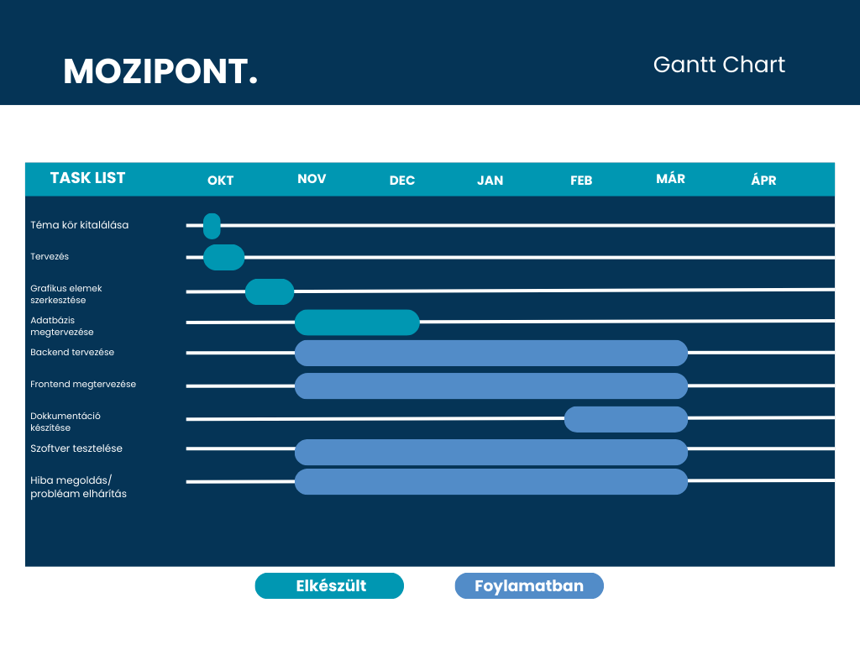
Fig. 1: Gantt chart

Gantt chart: own source

